

**SAVEETHA INSTITUTE OF MEDICAL AND TECHNICAL SCIENCES , CHENNAI – 602105**

**CAPSTONE PROJECT REPORT**

**TITLE**

**Hybrid cloud integration**

**Submitted to**

**SAVEETHA SCHOOL OF ENGINEERING**

**By**

G. Harshitha Reddy (192210677)

**Guided by**

Dr. j. Chenni Kumaran

**Abstract:** Hybrid cloud integration has emerged as a pivotal strategy for organizations seeking to leverage the benefits of both public and private cloud environments while managing their diverse workloads efficiently. This paper explores the challenges and opportunities associated with hybrid cloud integration, focusing on key technical considerations such as seamless data synchronization, interoperability between disparate systems, and maintaining robust security protocols. Additionally, it examines the role of integration platforms and middleware in facilitating smooth hybrid cloud operations, ensuring scalability, flexibility, and cost-effectiveness. Through a comprehensive review of current practices and technologies, the importance of strategic planning and adaptive infrastructure in harnessing the full potential of hybrid cloud environments for modern enterprises.

**Top of Form**

**Introduction:** In today's digital landscape, where agility and scalability are paramount, hybrid cloud integration has emerged as a strategic imperative for organizations aiming to optimize their IT infrastructures. The hybrid cloud model offers a compelling blend of flexibility and control by combining the advantages of public and private clouds, thereby accommodating varying workload demands and regulatory requirements. However, harnessing the full potential of hybrid cloud environments necessitates overcoming significant challenges in seamless data integration, interoperability, and security.

This introduction sets the stage for exploring the complexities and opportunities inherent in hybrid cloud integration. It underscores the critical role of integration platforms and middleware in bridging disparate cloud environments, enabling organizations to achieve operational efficiencies, scalability, and cost-effectiveness. By delving into these crucial aspects, this paper aims to provide insights into effective strategies for implementing and managing hybrid cloud infrastructures, thereby empowering enterprises to navigate the complexities of modern IT landscapes successfully.

The topic of "hybrid cloud integration" explores the strategy and implementation of combining both public and private cloud services within an organization's IT infrastructure. It involves seamlessly integrating and managing workloads across these different cloud environments to optimize performance, scalability, and cost-efficiency.

**Problem Statement:** The integration of hybrid cloud environments poses multifaceted challenges for organizations seeking to optimize their IT strategies. A primary concern is ensuring seamless data synchronization across public and private clouds to maintain consistency and accessibility, which is crucial for operational continuity and data-driven decision-making. Compatibility issues between different cloud platforms and legacy systems further complicate integration efforts, requiring meticulous attention to interoperability to facilitate smooth communication and workflow management.

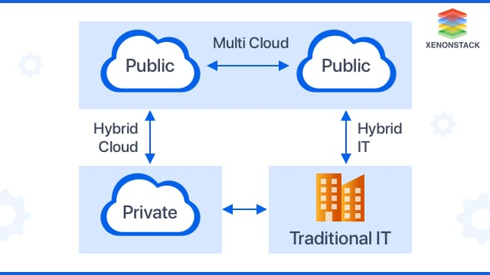

**Proposed Design Work:**

**Integration Architecture**

**Key components of integration architecture for hybrid cloud typically include:**

**1.Integration Patterns:** Defined approaches for integrating various components such as cloud services, on-premises systems, and external applications. Common patterns include point-to-point integration, hub-and-spoke integration, and event-driven architectures.

**2.Middleware and Integration Platforms**: Middleware solutions and integration platforms act as the middleware layer that facilitates communication between different systems and manages data transformation, routing, and orchestration. Examples include Apache Kafka, MuleSoft, and Azure Integration Services.

**3.API Management:** APIs (Application Programming Interfaces) play a critical role in enabling secure and standardized communication between different components in hybrid cloud environments. API management platforms help organizations govern and secure APIs while enabling seamless integration and interoperability.

**4.Data Integration and Synchronization:** Tools and frameworks for ensuring consistent and reliable data synchronization across hybrid environments, including data integration platforms and ETL (Extract, Transform, Load) tools. This ensures that data remains accurate and up-to-date across different cloud platforms and on-premises systems.

**5.Security and Governance:** Robust security measures and governance frameworks are essential to protect data and ensure compliance with regulatory requirements across hybrid cloud deployments. This includes identity and access management (IAM), encryption, and monitoring solutions to detect and respond to security threats.

**6.Scalability and Performance Optimization**: Architecture design considerations for scalability and performance optimization, such as load balancing, caching mechanisms, and auto-scaling capabilities to handle varying workload demands effectively.

**7.Monitoring and Management:** Tools and techniques for monitoring the health, performance, and usage of integrations and services within hybrid cloud environments. This includes real-time monitoring, logging, and analytics to optimize resource utilization and identify and resolve issues promptly.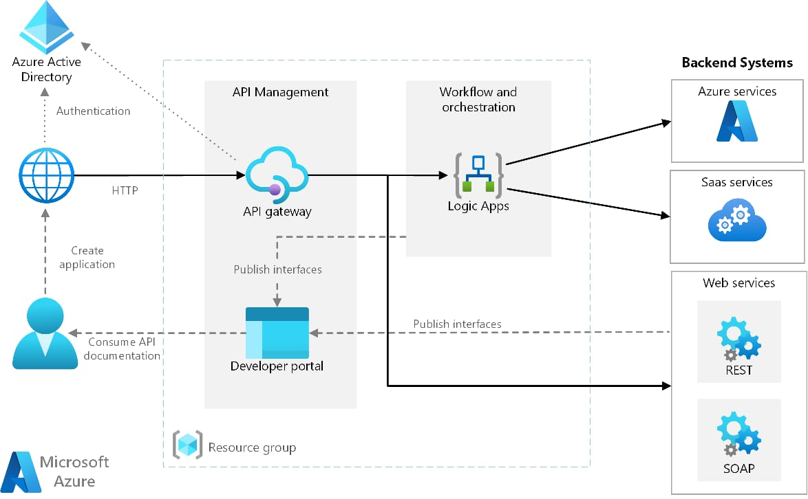

**2.Data Security and Compliance**

**Challenges in Hybrid Cloud Environments:**

**1.Data Security Data Encryption**: Implementing strong encryption mechanisms to protect data both at rest and in transit between public and private cloud environments.

**2.Identity and Access Management (IAM):** Enforcing strict access controls and authentication mechanisms to prevent unauthorized access to sensitive data and resources across hybrid cloud deployments.

**3.Data Loss Prevention (DLP):** Implementing policies and technologies to prevent accidental or intentional data loss, leakage, or unauthorized exposure.

**4.Compliance Requirements**: Ensuring adherence to industry-specific regulations (e.g., GDPR, HIPAA, PCI DSS) and organizational policies governing data privacy and security.

**5.Cloud Provider Security Measures**: Evaluating and understanding the security measures and certifications offered by cloud service providers (CSPs) for their respective public cloud services.

**Strategies for Ensuring Data Security and Compliance:**

**1.Data Classification and Lifecycle Management**: Classifying data based on sensitivity and applying appropriate security controls throughout its lifecycle, including creation, storage, processing, and deletion.

2.**Continuous Monitoring and Threat Detection**: Implementing real-time monitoring and threat detection mechanisms to detect and respond to security incidents promptly.

**3.Regular Security Assessments and Audits:** Conducting regular security assessments, penetration testing, and compliance audits to identify vulnerabilities, assess risks, and ensure adherence to security policies and regulatory requirements.

4.**Data Residency and Sovereignty**: Understanding data residency requirements and ensuring that sensitive data is stored and processed in compliance with local laws and regulations.

5.**Employee Training and Awareness**: Providing regular training and awareness programs to educate employees about data security best practices, phishing prevention, and incident response protocols.

**3.Performance and Reliability**

**Challenges in Performance and Reliability in Hybrid Cloud Environments:**

**1. Network Latency and Bandwidth**: Managing network latency and bandwidth constraints between public and private clouds can impact application performance.

2. **Resource Allocation and Load Balancing**: Efficiently allocating resources across hybrid environments to balance workloads and prevent over-provisioning or underutilization.

3. **Integration and Interoperability**: Ensuring seamless integration and interoperability between different cloud platforms, legacy systems, and applications can be complex.

4**. Data Consistency and Synchronization:** Maintaining data consistency and synchronization across hybrid cloud environments is essential for ensuring that applications have access to the latest data versions without inconsistencies or errors.

5. **Fault Tolerance and Disaster Recovery**: Designing and implementing fault-tolerant architectures and disaster recovery plans to mitigate the impact of hardware failures, network outages, or other unforeseen disruptions.

**Strategies for Enhancing Performance and Reliability:**

**1. Performance Monitoring and Optimization:** Implementing proactive monitoring tools and performance management solutions to track key performance metrics (e.g., response time, throughput, resource utilization) across hybrid environments**.**

**2. Scalability and Elasticity:** Leveraging cloud-native scalability features such as auto-scaling and elastic load balancing to dynamically adjust resource allocation based on fluctuating workload demands**.**

**3. Service Level Agreements (SLAs):** Establishing clear SLAs with cloud service providers and internal stakeholders to define performance expectations, uptime guarantees, and response times.

**4. Hybrid Cloud Architecture Design:** Designing resilient and fault-tolerant architectures that leverage redundancy, data replication, and geographic distribution to minimize single points of failure and enhance reliability.

**5. Testing and Validation**: Conducting thorough testing, validation, and performance tuning during the deployment phase and ongoing operations**.**

**4.Hybrid Cloud Management**

**Key Components of Hybrid Cloud Management:**

**1.Orchestration and Automation**: Utilizing orchestration tools and automation frameworks to streamline the deployment, provisioning, and management of workloads and resources across hybrid cloud environments

**2.Resource Allocation and Optimization**: Efficiently allocating and managing resources (compute, storage, networking) across public and private clouds based on workload requirements and performance metrics.

**3.Integration and Interoperability**: Facilitating seamless integration and interoperability between different cloud platforms, on-premises systems, and external applications.

**4.Security and Compliance**: Implementing comprehensive security measures and compliance controls to protect sensitive data and applications in accordance with regulatory requirements.

**5.Monitoring and Performance Management**: Deploying monitoring tools and performance management solutions to track key metrics (e.g., latency, throughput, resource utilization) and gain insights into the health and performance of hybrid cloud environments..

**6.Cost Management and Optimization**: Monitoring and optimizing cloud spending through cost management tools and analytics to track usage patterns, identify cost-saving opportunities, and enforce budget controls.

**7.Disaster Recovery and Business Continuity**: Developing and testing robust disaster recovery (DR) plans and business continuity strategies to ensure data resilience and minimize downtime in the event of disruptions or disasters.

**Strategies for Effective Hybrid Cloud Management**

1.**Strategic Planning**: Aligning hybrid cloud strategies with organizational goals and IT requirements to define clear objectives, governance policies, and implementation roadmaps.

2.**Vendor Management**: Collaborating with cloud service providers (CSPs) and third-party vendors to leverage their expertise, support services, and cloud solutions that meet specific business needs.

**3.Continuous Improvement**: Implementing a culture of continuous improvement and agility to adapt to evolving technologies, market dynamics, and organizational priorities.

**4.Training and Skill Development**: Investing in training and skill development programs to empower IT teams with the knowledge and expertise required to manage hybrid cloud environments effectively.

**5.Adoption of DevOps Practices**: Embracing DevOps principles and practices to foster collaboration, automation, and continuous delivery across hybrid cloud deployments, thereby enhancing agility and responsiveness.

**Cost analysis:**

Here are some key points and steps involved in cost analysis:

**1. Identification of Costs:** This involves identifying all the costs incurred in a particular activity or process. Costs can be categorized into direct costs (e.g., materials, labor directly related to production) and indirect costs (e.g., overhead costs like rent, utilities).

**2.Cost Estimation**: Estimating the monetary value of each cost item identified. This may involve historical data, market research, or expert judgment.

**3.Cost Classification:** Costs are classified based on their behavior (fixed vs. variable), relevance (sunk vs. incremental), or function (production vs. administration).

**4.Cost Behavior Analysis:** Understanding how costs behave in relation to changes in production levels or other factors. This helps in forecasting costs under different scenarios.

**5.Cost Control:** Implementing measures to manage and reduce costs where possible, ensuring efficiency and cost-effectiveness.

**6.Cost Allocation:** Allocating indirect costs to specific products, services, or projects. This is important for accurate pricing and profitability analysis**.**

**7.Cost-Benefit Analysis:** Evaluating the costs versus the benefits or returns generated by a particular project or decision. This helps in assessing the overall feasibility and profitability**.**

**8.Comparison and Benchmarking:** Comparing costs against industry benchmarks or competitors to identify areas for improvement or cost-saving opportunities.

**9.Reporting and Decision Making:** Presenting cost analysis findings to stakeholders to support decision-making processes, such as pricing strategies, budget allocations, or investment decisions.

**10.Continuous Monitoring:** Regularly reviewing and updating cost analysis to reflect changes in the business environment or operational conditions.

**DOCUMENTATION:**

**Hybrid Cloud Integration Documentation**

**Overview**

Hybrid cloud integration is the process of connecting and orchestrating workloads and data across a combination of on-premises, private cloud, and public cloud environments. This approach allows organizations to leverage the benefits of various cloud models, such as flexibility, scalability, and cost-effectiveness, while maintaining control over sensitive data and critical applications.

**Key Components**

1. **On-Premises Infrastructure**: Traditional data centers and private clouds that host critical and sensitive applications.

2. **Public Cloud Services**: Third-party cloud service providers (CSPs) like AWS, Microsoft Azure, Google Cloud Platform (GCP), etc.

3**.Private Cloud**: A dedicated cloud environment, often hosted on-premises or by a third party, providing increased security and control.

4**.Integration Platform**: Middleware or tools that enable seamless connectivity and data flow between different cloud environments.

**Benefits**

**1.Scalability**: Easily scale workloads using public cloud resources during peak demand periods.

**2.Cost Efficiency**: Optimize costs by leveraging public cloud for non-critical workloads while keeping sensitive data on-premises.

**3.Flexibility**: Deploy applications across multiple environments to meet specific business needs.

**4.Resilience**: Enhance disaster recovery and business continuity through diversified infrastructure.

**Challenges:**

**1.Complexity**: Managing and integrating multiple environments can be complex and require specialized skills.

**2.Security**: Ensuring consistent security policies and compliance across different environments.

**3.Latency**: Minimizing latency and ensuring reliable connectivity between on-premises and cloud resources.

**4.Data Management**: Handling data synchronization, consistency, and governance across hybrid environments.

**Integration Strategies:**

1**.Data Integration**: Synchronizing data between on-premises databases and cloud storage/services using ETL (Extract, Transform, Load) processes, data replication, and APIs.

2.**Application Integration**: Utilizing middleware, APIs, and microservices to connect applications across environments, ensuring seamless functionality and user experience.

3.**Network Integration**: Establishing secure and high-performance network connections using VPNs, Direct Connect, ExpressRoute, and other networking solutions.

4.**Management Tools**: Employing unified management tools and platforms to monitor, manage, and orchestrate resources across hybrid environments**.**

**Best Practices:**

1.**Security and Compliance**: Implement robust security measures, including encryption, identity and access management (IAM), and regular audits to ensure compliance with regulations.

2.**Automation**: Use automation tools for provisioning, scaling, and managing resources to reduce manual efforts and minimize errors.

3.**Monitoring and Optimization**: Continuously monitor performance, usage, and costs to optimize resource allocation and improve efficiency.

4.**Disaster Recovery**: Develop and regularly test disaster recovery plans to ensure business continuity in case of failures or outages.

5.**Vendor Management**: Maintain good relationships with cloud service providers and stay updated on their offerings and best practices.

**Use Cases:**

1.**Cloud Bursting**: Temporarily extending on-premises applications to the public cloud during peak demand to avoid over-provisioning of on-premises resources.

2.**Data Archiving**: Storing infrequently accessed data in cost-effective public cloud storage while keeping active data on-premises.

3.**Dev/Test Environments**: Utilizing public cloud for development and testing environments to speed up development cycles and reduce costs.

4.**Disaster Recovery**: Leveraging public cloud for disaster recovery to ensure rapid recovery and minimal downtime.

**Tools and Technologies:**

**1.Integration Platforms**: MuleSoft, Dell Boomi, Microsoft Azure Logic Apps, IBM App Connect. Data Integration ToolsTalend, Informatica, Apache Kafka, AWS Glue.

**2.Network Solutions:** AWS Direct Connect, Azure ExpressRoute, Google Cloud Interconnect.

**3.Management Tools**: VMware realize, Red Hat CloudForms, IBM Cloud Pak for Mult iCloud Management.

**Conclusion:**

Hybrid cloud integration offers a strategic approach for organizations to modernize their IT infrastructure, balancing control, security, and cost-efficiency. By integrating on-premises systems with private and public cloud environments, businesses can leverage the scalability and flexibility of the cloud while retaining control over sensitive data and critical applications. This approach allows for easy scalability to meet changing demands and the deployment of applications across diverse environments tailored to specific business needs. Cost optimization is achieved by using cost-effective public cloud resources for non-critical workloads while preserving on-premises infrastructure for sensitive data. Additionally, hybrid cloud integration enhances resilience, improving disaster recovery and business continuity through a diversified infrastructure, ensuring high availability and minimal downtime. Innovation and agility are accelerated by leveraging cloud-based development and testing environments and adopting modern cloud-native technologies. However, challenges such as complexity management, security, compliance, and performance optimization must be addressed. Implementing unified management tools, embracing automation, and maintaining strong vendor relationships are essential best practices. In summary, hybrid cloud integration empowers organizations to blend control, performance, and cost savings, driving innovation and ensuring robust resilience in an ever-evolving digital landscape.